CDC EHR Health IT Zika Outbreak Workgroup

An approach for eliciting travel history in standardized form that can be used in Electronic Health Record (EHR) and Public Health Surveillance System. This would be useful for Public Health Case Reporting as well as to implement interim guidelines associated with an outbreak in EHR.
Travel History
Data Elements

Travel History

Detailed travel history is required to implement the interim guidelines associated with Zika outbreak. This document includes LOINC code proposals for EHR as well as public health surveillance systems.

References from CDC’s Zika Outbreak interim guidelines regarding travel history
- Identify pregnant women who have traveled to areas with ongoing transmission of Zika virus.
- Identify women of reproductive age who reside in areas with ongoing transmission of Zika virus.
- Identify pregnant patients who are considering travel to an area with Zika virus transmission.
- Identify women trying to become pregnant who are considering travel to an area with Zika virus transmission be counseled.
- Identify pregnant women whose male partners have or are at risk for Zika virus infection.
- Identify the pregnant women who may need lab testing based upon travel history information.
  - Testing can be offered between 2 and 12 weeks after pregnant women return from travel to areas with ongoing Zika virus transmission.

CDC Zika Outbreak 2016 -Interim Guidelines for Healthcare Providers
- Update: Interim Guidelines for Health Care Providers Caring for Pregnant Women and Women of Reproductive Age with Possible Zika Virus Exposure – United States, 2016 (Feb. 5, 2016)
  - Questions and Answers for Healthcare Providers Caring for Pregnant Women and Women of Reproductive Age with Possible Zika Virus Exposure(http://www.cdc.gov/zika/hc-providers/qa-pregnant-women.html)
- Update: Interim Guidelines for Healthcare Providers Caring for Infants and Children with Possible Zika Virus Infection – United States, February 2016
  - Questions and Answers for Healthcare Providers Caring for Infants and Children with Possible Zika Virus Infection(http://www.cdc.gov/zika/hc-providers/qa-pediatrician.html)

California Zika Case Report Form:
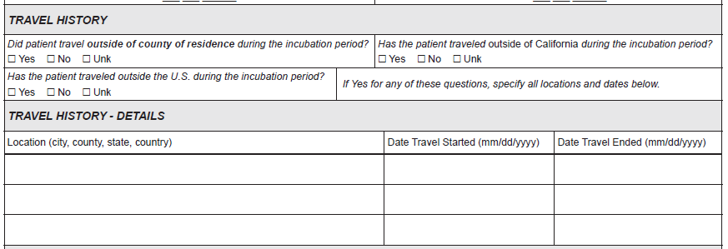
Texas Arboviral Case Report Form:
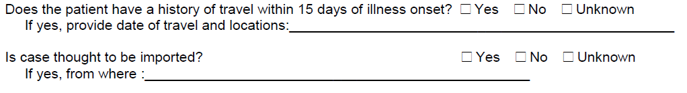

North Carolina Zika Case Report Form (interim)
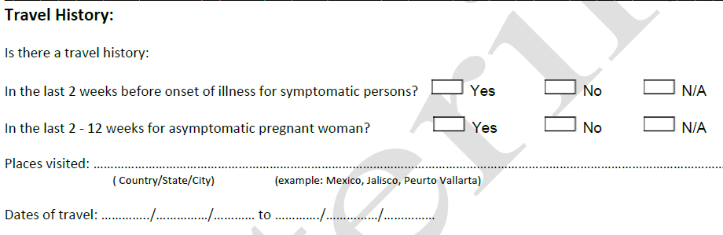

Existing Travel related LOINC codes:

LOINC Code | Long Name | Component | Property | Timing | System | Scale | Method
8691-8 | History of travel | History of travel | Find | Pt | ^Patient | Nom | Reported
10182-4 | History of travel Narrative | History of travel | Find | Pt | ^Patient | Nar | Reported

Travel History Data Element Modeling:
Recent travel to endemic area of disease being investigated or reported - For EHR Usage – Screening Question
Proposal:

LOINC Code | Long Name | Component | Property | Timing | System | Scale | Method | Value Set/  Answer List
New | Recent travel to endemic area of disease being investigated or reported [Location] | Recent travel to endemic area | Loc | Pt | ^Patient | Nom |  | CDC Travel Notice Website  e.g.  Zika affected areas

Value Set: PHVS_ZikaAffectedAreas_CDC

https://phinvads.cdc.gov/vads/ViewValueSet.action?oid=2.16.840.1.114222.4.11.7457
Synchronized with http://www.cdc.gov/zika/geo/index.html using standard vocabulary codes
Screenshot of PHIN VADS value set – Zika affected areas
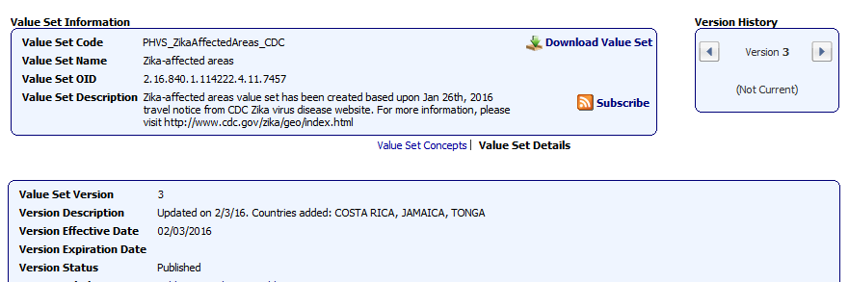
- This is a generic data element that can be used for all the infectious diseases in EHR.
- This will be used as an initial screening question. If the patient has traveled to endemic area recently, then the specific travel details would be collected.
- Recent travel timeline can be associated with incubation period of a pathogen being investigated (Ebola = 21 days, Zika = 7 days)
Screenshot about Incubation period from CSTE Travel History Pilot Project
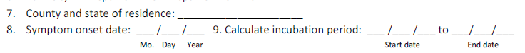
- Value set (answer list) would be created specifically for a particular condition based upon CDC travel notice / alert website - http://wwwnc.cdc.gov/travel/notices
  - “Zika affected areas” usually contains countries, but it also could include jurisdictions such as State/Provinces, City and County. http://www.cdc.gov/zika/geo/index.html
  - “Ebola affected areas”
- Value set versions would be used to associate with a specific outbreak event which can be associated with a date, month, year and location.
  - PHIN VADS value set link based upon Value set OID always links to the latest version
https://phinvads.cdc.gov/vads/ViewValueSet.action?oid=2.16.840.1.114222.4.11.7457
  - Each value set version has an effective date which are usually updated based upon CDC’s travel notice. https://phinvads.cdc.gov/vads/ViewValueSet.action?id=B7A7387F-ECCA-E511-9D24-0017A477041A#
  - When the outbreak is over, expiry date would be included in value set version metadata.
  - PHIN VADS has RSS feeds which would also allow users to see the changes.
Travel History Details:
- Travel Destination / Location
  - Country = ISO 3166-1 (3 character codes)
  - Provinces / Country Sub-divisions: ISO 3166-2 , U.S. States = FIPS 5-2
  - City = USGS GNIS / FIPS 55-3
  - County = FIPS 6-4
- Date Travel Started
- Date Travel Ended

Proposal:
Many of the disease specific case report forms gather information about the recent travel locations which could be country, state, city or county.

LOINC Code | Long Name | Component | Property | Timing | System | Scale | Method | Value Set / Answer List
New | Date travel started | Date travel started | Date | Pt | ^Patient | Qn
New | Date travel ended | Date travel ended | Date | Pt | ^Patient | Qn
New | Country visited | Country visited | Loc | Pt | ^Patient | Nom |  | ISO 3166-1
New | Country Sub-division /State/Province visited | Country Sub-division/State/Province visited | Loc | Pt | ^Patient | Nom |  | ISO 3166-2  FIPS 5-2
New | City visited | City visited | Loc | Pt | ^Patient | Nom |  | USGS GNIS / FIPS 55-3
New | County visited | County visited | Loc | Pt | ^Patient | Nom |  | FIPS 6-4
For public health case reporting, the following leading questions are usually asked in case report forms to identify the travel outside their county and state of residence.
CSTE Surveillance Practice and Implementation Workgroup – Travel History Pilot Project (Draft Version)
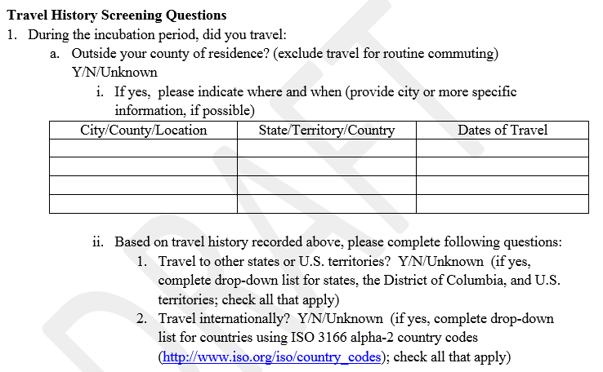
Proposal:
LOINC Code | Long Name | Component | Property | Timing | System | Scale | Method | Value Set / Answer List
New | History of travel outside the county of residence | History of travel outside the county of residence | Find | Incubation Period | ^Patient | Nom |  | Yes No Unknown
New | History of travel outside the state of residence | History of travel outside the state of residence | Find | Incubation Period | ^Patient | Nom |  | Yes No Unknown
New | Incubation period start date | Incubation period start date | Date | Pt | ^Pathogen | Qn
New | Incubation period end date | Incubation period end date | Date | Pt | ^Pathogen | Qn

Existing LOINC Codes related to exposure locations used in Generic Case Notification:
LOINC Code | Long Name | Component | Property | Timing | System | Scale | Method
77984-3 | Country of exposure to illness [Location] | Country of exposure to illness | Loc | Pt | ^Patient | Nom
77985-0 | State or province of exposure to illness | State or province of exposure to illness | Loc | Pt | ^Patient | Nom
77986-8 | City of exposure to illness | City of exposure to illness | Loc | Pt | ^Patient | Nom
77987-6 | County of exposure to illness [Location] | County of exposure to illness | Loc | Pt | ^Patient | Nom
55218-2 | Date of actual exposure to blood/body fluid | Date of actual exposure to blood &or body fluid | Date | Pt | ^Patient | Qn

